**Textile Auxiliaries**

**Project Code**

**Project Advisor**

<Name of the project internal advisor> (internal)

<Name of the project external advisor (if any)> (external)

**Project Manager**

**Project Team**

Muhammad Abuzar 17-uglc-420(Leader)

Haseeb Anwar BSCSF18E043

Danish Tahir 17-uglc -445

**Table of Contents**

Chapter 01 4

1.1 Introduction 4

1.2 Project Overview 4

1.3 Background and Justification 4

1.4 Project Goals/Objectives 5

1.5 Project Methodology 5

1.6 Project Scope 6

1.7 High level Project Plan 7

1. Tools are used in the project: 8

CHAPTER 02 9

2.1 Introduction 9

1. Purpose of Document 9

2. Project Overview 9

3. Scope 9

2.2 Overall System Description 10

1. User characteristics 10

2. Operating environment 10

3. System constraints 10

2.3 External Interface Requirements 11

1. Hardware Interfaces 11

2. Software Interfaces 11

2.4 Functional Requirements. 11

1. Admin 11

2. Owners 11

3. End-Users 12

2.5 Non-functional Requirements 12

1. Performance Requirements 12

2. Security Requirements 12

3. User Documentation 12

Chapter 03 13

3.1 Introduction 13

1. Purpose of Document 13

2. Project Overview 13

3.2 System Architecture 13

3.3 Use Cases 14

1. Use case diagrams 14

2. Use Case Description 15

3.4 High Level Design 26

1. ER Diagram 26

Chapter 04 27

4.1 Introduction 27

1. Purpose of Document 27

2. Project Overview 27

4.2 Class Diagram 28

4.3 System Sequence Diagrams 28

1. Admin 28

2. Owner 29

3. User 29

# Chapter 01

## Introduction

We continue to shape our personality all our life. We make our personalities attractive all our lives. Of these, clothes are the most important. This work is done in textiles. In the conventional system, the Buyer party had to make meetings with the factory’s owner or manager. In which, more time was needed as the party goes to many factories. And it was waste of time.

That is why we are going to make the textile work in this project open-source. ‏We are creating an online web integrated and mobile application based system for Textile Industries. The **Textile Auxiliaries** is a platform for buying and selling services and goods such as yarn, cloth, and clothing. In this seller provides all information about our services. And the buyer can also request services. This is beneficial for both parties as compared to the conventional system because it saves time and physical efforts like go and check the services of different industries.

In this project, we provide business-to-consumer (B2C) and business-to-business (B2B) sales services via a web portal and mobile applications as well as electronic payment services and real-time tracking of orders. It owns and operates a diverse portfolio of companies in numerous business sectors. We provide the web portal and mobile application to the sellers where they create their account first. Were (1) Seller provides its goods or services details. (2) The buyer uploads their requests or searches for the services which they need. (3) Both can receive or make orders, track their orders. (4) The buyer can post their request by their requirements. (5) There is no need for a third-party person for the contract between both parties (seller and buyer). (6) It provides the nearest services provider to the requester.

## Project Overview

Many textile sites are contributing to this but no site provides everything from raw materials to finished products. For example, in OLX [1], the only ready-made cloth is available. We can't make our designs and colors. Similarly, there is another website called “Wal-Mart [2]” in which they also give the option to select the colors of the fabric, but even here we cannot design the fabric on our own. We can order by selecting one of the designs that they already have.

We are adding to them that we can produce goods in custom design, colors and quality. Like they can make their goods by sending their design to the seller. There are some things we are adding to it, such as the seller may request the buyer that we have to produce goods in such a design, colors and quality which the buyer provides. And also, the seller can upload his services to see what he is providing. This is beneficial for both parties as compared to the conventional system because it saves time and physical efforts like go and check the services of different industries. There are some advance and security features like privacy, tacking and monitoring of orders, analytics of seller, ratings, chatbots etc.

## Background and Justification

Many textile sites are contributing to this but no site provides everything from raw materials to finished products. For example, in OLX[1], the only ready-made cloth is available. We can't make our designs and colors. Similarly, there is another website called “Wal-Mart[2]” in which they also give the option to select the colors of the fabric, but even here we cannot design the fabric on our own. We can order by selecting one of the designs that they already have.

We are adding to them that we can produce goods in custom design, colors and quality. Like they can make their goods by sending their design to the seller. There are some things we are adding to it, such as the seller may request the buyer that we have to produce goods in such a design, colors and quality which the buyer provides. And also, the seller can upload his services to see what he is providing. This is beneficial for both parties as compared to the conventional system because it saves time and physical efforts like go and check the services of different industries. There are some advance and security features like privacy, tacking and monitoring of orders, analytics of seller, ratings, chatbots etc.

## Project Goals/Objectives

In this project, we provide business-to-consumer (B2C) and business-to-business (B2B) sales services via a web portal and mobile applications as well as electronic payment services and real-time tracking of orders. It owns and operates a diverse portfolio of companies in numerous business sectors. We provide the web portal and mobile application to the sellers where they create their account first. Were (1) Seller provides its goods or services details. (2) The buyer uploads their requests or searches for the services which they need. (3) Both can receive or make orders, track their orders. (4) The buyer can post their request by their requirements. (5) There is no need for a third-party person for the contract between both parties (seller and buyer). (6) It provides the nearest services provider to the requester.

## Project Methodology

In this project we are going to use Modified Waterfall SDLC Model. The following figure is showing the phases which we will use to develop our project. This model is consisting of six phases.

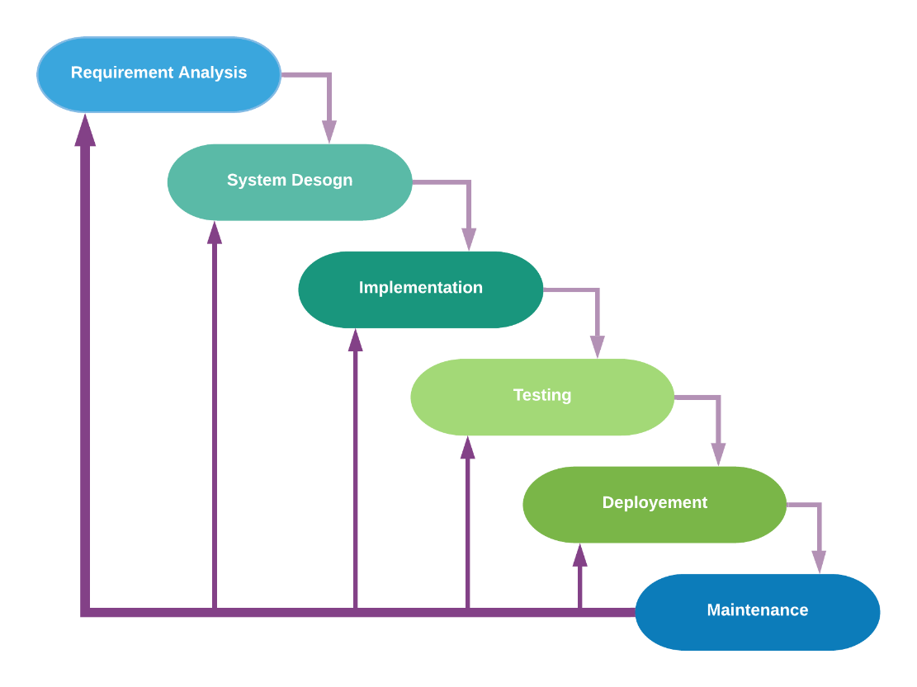

Figure 1: Modified Water Fall Model

* **Requirements Analysis:**The first phase involves understanding what needs to design and what is its function, purpose, etc. Here, the specifications of the input and output or the final product are studied and marked.
* **System Design:** The requirement specifications from the first phase are studied in this phase and system design is prepared. System Design helps in specifying hardware and system requirements and also helps in defining overall system architecture. The software code to be written in the next stage is created now.
* **Implementation:** With inputs from system design, the system is first developed in small programs called units, which are integrated into the next phase. Each unit is developed and tested for its functionality which is referred to as Unit Testing.
* **Testing:** All the units developed in the implementation phase are integrated into a system after testing of each unit. The software designed, needs to go through constant software testing to find out if there are any flaw or errors. Testing is done so that the client does not face any problem during the installation of the software.
* **Deployment:** Once the functional and non-functional testing is done, the product is deployed in the customer environment or released into the market.
* **Maintenance:** This step occurs after installation, and involves making modifications to the system or an individual component to alter attributes or improve performance. These modifications arise either due to change requests initiated by the customer, or defects uncovered during live use of the system. The client is provided with regular maintenance and support for the developed software.

## Project Scope

That is why we are going to make the textile work in this project open-source. ‏We are creating an online web integrated and mobile application based system for Textile Industries. The Textile Auxiliaries is a platform for buying and selling services and goods such as yarn, cloth, and clothing. In this seller provides all information about our services. And the buyer can also request services. This is beneficial for both parties as compared to the conventional system because it saves time and physical efforts like go and check the services of different industries.

In this project, we provide:

* Business-to-consumer (B2C) and business-to-business (B2B) sales services via a web portal and mobile applications as well as electronic payment services and real-time tracking of orders.
* It owns and operates a diverse portfolio of companies in numerous business sectors.
* We provide the web portal and mobile application to the sellers where they create their account first. Were
  + Seller provides its goods or services details.
  + The buyer uploads their requests or searches for the services which they need.
  + Both can receive or make orders, and also can track their orders.
  + The buyer can post their request by their requirements.
  + There is no need for a third-party person for the contract between both parties (seller and buyer).
  + It provides the nearest services provider to the requester.

## High level Project Plan

|  |  |  |
| --- | --- | --- |
| **Column1** | **Column2** | **Column3** |
|  |  |  |
|  | **Textile Auxiliaries** | |
| Task | Start Date | Days to Finish |
| Requirements | 31-Oct-21 | 15 |
| Research | 15-Nov-21 | 10 |
| Planning | 23-Nov-21 | 8 |
| Design 1 | 01-Dec-21 | 20 |
| Design 2 | 22-Dec-21 | 20 |
| Design 3 | 15-Jan-22 | 20 |
| Design 4 | 06-Feb-22 | 20 |
| Development | 01-Mar-22 | 30 |
| Testing | 02-Apr-22 | 10 |
| Maintain | 13-Apr-22 | 10 |

Following are the high-level plan of our project. We set the timeline of project from the 30 September 2020 to 6 Feb 2021.

### Tools are used in the project:

* Android studio (for Android App)
* Php Storm
* Php My Admin

# CHAPTER 02



## Introduction



### Purpose of Document

The purpose of this document is to give a detailed description of the requirements for the “Textile Auxiliaries” software. It will illustrate the purpose and complete declaration for the development of system. It will also explain system constraints, interface and interactions with other external applications. This document is primarily intended to be proposed to a customer for its approval and a reference for developing the first version of the system for the development team.

### Project Overview

Many textile sites are contributing to this but no site provides everything from raw materials to finished products. For example, in OLX [1], the only ready-made cloth is available. We can't make our designs and colors. Similarly, there is another website called “Wal-Mart [2]” in which they also give the option to select the colors of the fabric, but even here we cannot design the fabric on our own. We can order by selecting one of the designs that they already have.

We are adding to them that we can produce goods in custom design, colors and quality. Like they can make their goods by sending their design to the seller. There are some things we are adding to it, such as the seller may request the buyer that we have to produce goods in such a design, colors and quality which the buyer provides. And also, the seller can upload his services to see what he is providing. This is beneficial for both parties as compared to the conventional system because it saves time and physical efforts like go and check the services of different industries. There are some advance and security features like privacy, tacking and monitoring of orders, analytics of seller, ratings, chatbots etc.

### Scope

That is why we are going to make the textile work in this project open-source. ‏We are creating an online web integrated and mobile application based system for Textile Industries. The Textile Auxiliaries is a platform for buying and selling services and goods such as yarn, cloth, and clothing. In this seller provides all information about our services. And the buyer can also request services. This is beneficial for both parties as compared to the conventional system because it saves time and physical efforts like go and check the services of different industries.

In this project, we provide:

* Business-to-consumer (B2C) and business-to-business (B2B) sales services via a web portal and mobile applications as well as electronic payment services and real-time tracking of orders.
* It owns and operates a diverse portfolio of companies in numerous business sectors.
* We provide the web portal and mobile application to the sellers where they create their account first. Were
  + Seller provides its goods or services details.
  + The buyer uploads their requests or searches for the services which they need.
  + Both can receive or make orders, and also can track their orders.
  + The buyer can post their request by their requirements.
  + There is no need for a third-party person for the contract between both parties (seller and buyer).
  + It provides the nearest services provider to the requester.

## Overall System Description

This section will give an overview of the whole system. The system will be explained in its context to show how the system interacts with other systems and introduce the basic functionality of it. It will also describe what type of stakeholders that will use the system and what functionality is available for each type. At last, the constraints and assumptions for the system will be presented.



### User characteristics

* **Administrator**

The system administrator is given specific permission for managing and controlling the system.

* **Textile Owner**

Someone who has a Textile industry and wants his industry to be a part of the Application or online system.

* **User**

Someone who interacts with the mobile phone application. User could be the owner of the industry or a common person.

### Operating environment

* **Android**

This application is compatible with all android versions. Minimum Android version this application is 4.0.

* **iOS**

This application is also can run on all latest iOS versions. Minimum version is 10.0 required (if do so).

* **Windows**

The application also runs on all windows versions. It supports Windows XP, 7, 8, 8.1, and Windows 10.

* **Browsers**

It supports all browsers and search engines with all versions. Like, Google Chrome, Worldwide Web, Internet Explorer, Firefox, Apple Safari, Mozilla Firefox, Line Mode Browser, Opera, and Netscape Navigator.

### System constraints

* **GPS**

Both Web-portal and the mobile application, the system interacts with the GPS navigation system on the mobile phone. Since there are multiple systems and multiple GPS manufacturers, the interface will most likely not be the same for every one of them.

* **Internet**

Internet connection is also a constraint for the application. Since the application fetches data from the database over the Internet, there must be an active Internet connection for the application for its proper functionality.

* **User Data**

The Web Portal and the Mobile Application constrained by the capacity of the database. Since the database is shared between both Applications may be forced to queue incoming requests, orders and therefore increase the time it takes to fetch data.

This Application for all type of users.

## External Interface Requirements



### Hardware Interfaces

That is an Android based and Web-based application which runs on any kind of devices which supports web browsers and search engines. So, there is no need of any special kind of hardware and software.

### Software Interfaces

The mobile application communicates with the GPS application to get geographical information about where the user is located and the visual representation of it, and with the database to get the information about the Textiles. The communication between the database and the web portal consists of operation concerning both reading and modifying the data, and also the mobile application consists of the same operations.

## Functional Requirements.








### Admin

* Login:

Login for admin with admin privileges.

* Verify the Industries:

Admin has the right to verify the industries.

* Reject the Industries:

Admin has the right to reject the industries.

* Manage Industries:

Admin has the right to manage the industries.

* Manage End Users:

Admin has the right to manage the End Users.

* Manage Industries Information.
* For Reviews and ratings:

Trustpilot tool will use for reviews and rating system.

### Owners

* Create Account on the Web-Portal.
* Registration:

Register from the system.

* Credentials for registration
* Login:

User name & password

* Create ads

Provides the details of products or services. Like, Name, Pricing, Category, Quality, Colors, Quantity,

* Add, Edit & Delete Ads:

Owner can Create, Edit and Delete ads of their goods and service.

* Send offers to Buyers Requests.
* Main Dashboard to manage their orders.

### End-Users

* Download the application or Go to Web-Portal:
* Application should be cost-free:

Everyone can download on Devices.

* Registration: Register from the system
* Credentials for registration
* Profile page:

Where show orders, requests, personal information etc.

* Search:

Users can search what they need.

* Filters:

Users can filter Ads by Pricing, categories, industries, and Location.

* Search Result:

If no search result found then show relevant Ads.

* Post Requests:

Users can post requests by providing the details. Like, Quantity, Quality, Pricing, Time Duration, Category.

## Non-functional Requirements



### Performance Requirements

* **Scalability:** Textile Auxiliaries needs to be scalable so if we want to add a new function or feature it can be added easily
* **Availability:** Textile Auxiliaries requires high availability in the monitoring and control, communication and should be available 24/7.
* **Reliability:** Textile Auxiliaries requires an appropriate level of reliability in technologies, devices, communication and services.

### Security Requirements

Security requirements can be studied by examining the overall process. When a user wants to login their Account, Admin will Authenticate their information which is given by the user in the signup time, after that, the admin will permit login

### User Documentation

This is a Student Project so there is no User Documentation and User Manual.

# Chapter 03



## Introduction

### Purpose of Document

The purpose of this document is to give a detailed description of the requirements for the “**Textile Auxiliaries**” software. It will illustrate the purpose and complete declaration for the development of system. It will also explain system constraints, interface and interactions with other external applications. This document is primarily intended to be proposed to a customer for its approval and a reference for developing the first version of the system for the development team.

### Project Overview

Many textile sites are contributing to this but no site provides everything from raw materials to finished products. For example, in OLX [1], the only ready-made cloth is available. We can't make our designs and colors. Similarly, there is another website called “Wal-Mart [2]” in which they also give the option to select the colors of the fabric, but even here we cannot design the fabric on our own. We can order by selecting one of the designs that they already have.

We are adding to them that we can produce goods in custom design, colors and quality. Like they can make their goods by sending their design to the seller. There are some things we are adding to it, such as the seller may request the buyer that we have to produce goods in such a design, colors and quality which the buyer provides. And also, the seller can upload his services to see what he is providing. This is beneficial for both parties as compared to the conventional system because it saves time and physical efforts like go and check the services of different industries. There are some advance and security features like privacy, tacking and monitoring of orders, analytics of seller, ratings, chatbots etc.

## System Architecture

## Use Cases

### Use case diagrams

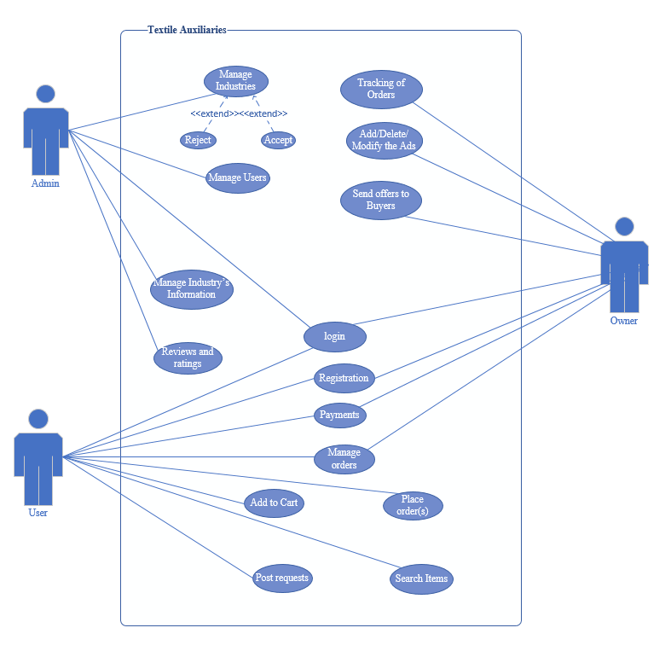

### Use Case Description

|  |  |  |  |  |
| --- | --- | --- | --- | --- |
| **1: Login** | | | | |
| **Actors:**  Administrator, Owners and Users | | | | |
| **Feature:** Authentications | | | | |
| **Use case Id:** | | 1 | | |
| **Pre-condition:** | | User should have internet connection and Application or Website of the system | | |
| **Scenarios** | | | | |
| **Step#** | **Action** | | | **Software Reaction** |
|  | If user is Login as Admin | | | Login the user with Admin Privileges |
| **2.** | If user is Login as Owner | | | Login the user with owner Privileges |
| **3** | If user is Login as User | | | Login the user with user Privileges |
| **Alternate Scenarios:** *Write additional, optional, branching or iterative steps. Refer to specific action number to ensure understandability.* | | | | |
| **1a:**  **2a:** | | | | |
| **Post Conditions** | | | | |
| **Step#** | **Description** | | | |
| 1. **Login** | User login and go to its Home Page | | | |
| 1. **Privileges** | Login the user with its Privileges as provided | | | |
|  |  | | | |
| **Use Case Cross referenced** | | | *<Related use cases, which use or are used by this use case>* | |
| **User Interface reference** | | | *List user interface(s) that are related to this use case. Use numbered list in case of more than one user interface elements.* | |
| **Concurrency and Response** *Give an estimate of the following*   * *Number of concurrent users* * *Expected response time of the use case* | | | | |

|  |  |  |  |  |
| --- | --- | --- | --- | --- |
| **2: Manage Industries** | | | | |
| **Actors:**  Admin | | | | |
| **Feature:** Admin can Add, Remove, Approve or Reject an Industries | | | | |
| **Use case Id:** | | 2 | | |
| **Pre-condition:** | | User should have the Admin Privileges to manages the industries | | |
| **Scenarios** | | | | |
| **Step#** | **Action** | | | **Software Reaction** |
| **1.** | If Admin wants to Add new industry to the system then click on add in manage industries. | | | Add a new Industry to the system. |
| **2.** | If Admin wants to Remove industry from the system then click on Remove in manage industries. | | | Remove already existed an Industry from the system. |
|  | Admin can Approve/Accept the request for registration in the system. | | | Approve/Accept an Industry for registration and add to the system. |
|  | Admin can Reject the request for registration in the system. | | | Reject the request of an Industry for registration. |
| **Alternate Scenarios:** *Write additional, optional, branching or iterative steps. Refer to specific action number to ensure understandability.* | | | | |
| **1a:**  **2a:** | | | | |
| **Post Conditions** | | | | |
| **Step#** | **Description** | | | |
| **If Admin Add industry** | An Industry is added to the system. | | | |
| **If Admin Remove industry** | An Industry is removed from the system | | | |
| **If Admin Approve/Accept industry** | Accept or reject the industry request for registration | | | |
| **If Admin Reject industry** | Reject the request of an industry | | | |
| **Use Case Cross referenced** | | | *<Related use cases, which use or are used by this use case>* | |
| **User Interface reference** | | | *List user interface(s) that are related to this use case. Use numbered list in case of more than one user interface elements.* | |
| **Concurrency and Response** *Give an estimate of the following*   * *Number of concurrent users* * *Expected response time of the use case* | | | | |

|  |  |  |  |  |
| --- | --- | --- | --- | --- |
| **3: Manage Users** | | | | |
| **Actors:**  Admin | | | | |
| **Feature:** Admin can Remove or Reject user | | | | |
| **Use case Id:** | | 3 | | |
| **Pre-condition:** | | User should have the Admin Privileges to manages the users | | |
| **Scenarios** | | | | |
| **Step#** | **Action** | | | **Software Reaction** |
|  | If Admin wants to Remove user from the system then click on Remove in manage users. | | | Remove already existed users from the system. |
|  | Admin allow permissions to the users. | | | Allow the permissions to the user. Like add delete and modify their ads. |
| **Alternate Scenarios:** *Write additional, optional, branching or iterative steps. Refer to specific action number to ensure understandability.* | | | | |
| **1a:**  **2a:** | | | | |
| **Post Conditions** | | | | |
| **Step#** | **Description** | | | |
| **If Admin Remove user** | The user Removed from the system. | | | |
| **Use Case Cross referenced** | | | *<Related use cases, which use or are used by this use case>* | |
| **User Interface reference** | | | *List user interface(s) that are related to this use case. Use numbered list in case of more than one user interface elements.* | |
| **Concurrency and Response** *Give an estimate of the following*   * *Number of concurrent users* * *Expected response time of the use case* | | | | |

|  |  |  |  |  |
| --- | --- | --- | --- | --- |
| **4: Registration** | | | | |
| **Actors:**  Owners and users | | | | |
| **Feature:** Registration of users in the system | | | | |
| **Use case Id:** | | 4 | | |
| **Pre-condition:** | | To register with the system, you need to have a good internet connection and a device to visit the website | | |
| **Scenarios** | | | | |
| **Step#** | **Action** | | | **Software Reaction** |
| **1.** | If user wants to Register as Owner. | | | Register a user as owner and provide the owner privileges. |
| **2.** | If user wants to Register as User. | | | Register a user as common user and provide the common user privileges. |
| **Alternate Scenarios:** *Write additional, optional, branching or iterative steps. Refer to specific action number to ensure understandability.* | | | | |
| **1a:**  **2a:** | | | | |
| **Post Conditions** | | | | |
| **Step#** | **Description** | | | |
| **If user Register as Owner** | A user is created as owner in the system. | | | |
| **If user Register as Owner** | A user is created as user in the system. | | | |
|  |  | | | |
| **Use Case Cross referenced** | | | *<Related use cases, which use or are used by this use case>* | |
| **User Interface reference** | | | *List user interface(s) that are related to this use case. Use numbered list in case of more than one user interface elements.* | |
| **Concurrency and Response** *Give an estimate of the following*   * *Number of concurrent users* * *Expected response time of the use case* | | | | |

|  |  |  |  |  |
| --- | --- | --- | --- | --- |
| **5: Ads** | | | | |
| **Actors:** Owner | | | | |
| **Feature:** Add/delete and modify Adds | | | | |
| **Use case Id:** | | 5 | | |
| **Pre-condition:** | | The user must log in into the system as the owner to upload their goods services which they are providing. | | |
| **Scenarios** | | | | |
| **Step#** | **Action** | | | **Software Reaction** |
| **1.** | If the owner wants to create an Ad(s) | | | Create an ad(s) |
| **2.** | If the owner wants to delete an Ad(s) | | | Delete an ad(s) |
|  | If the owner wants to modify an Ad(s) | | | Modify an ad(s) |
| **Alternate Scenarios:** *Write additional, optional, branching or iterative steps. Refer to specific action number to ensure understandability.* | | | | |
| **1a:**  **2a:** | | | | |
| **Post Conditions** | | | | |
| **Step#** | **Description** | | | |
| **If owner Add ad** | Ad is created in the system and post it for search. | | | |
| **If owner Delete** | Delete the ad(s) from the system | | | |
| **If owner Modify** | Modify the specified ad(s) | | | |
| **Use Case Cross referenced** | | | *<Related use cases, which use or are used by this use case>* | |
| **User Interface reference** | | | *List user interface(s) that are related to this use case. Use numbered list in case of more than one user interface elements.* | |
| **Concurrency and Response** *Give an estimate of the following*   * *Number of concurrent users* * *Expected response time of the use case* | | | | |

|  |  |  |  |  |
| --- | --- | --- | --- | --- |
| **6: Manage Orders** | | | | |
| **Actors:** Owner and User | | | | |
| **Feature:** Users can track their orders | | | | |
| **Use case Id:** | | *6* | | |
| **Pre-condition:** | | Log in into their account | | |
| **Scenarios** | | | | |
| **Step#** | **Action** | | | **Software Reaction** |
| **1.** | If user want to see their orders and click on Orders. | | | Show total orders. |
| **2.** | If user want to see their pending orders and click on pending Orders. | | | Show orders which have not completed yet. |
|  | If user want to see their completed orders and click on completed Orders. | | | Show completed orders. |
|  | If user want to see their active orders and click on active Orders. | | | Show orders which is on working. |
|  | If user want to see their starred orders and click on starred Orders. | | | Show priority orders. |
|  | If a user cancels an order(s). | | | Add the ordered items to inventory/store.  And mark the order as canceled. |
| **Alternate Scenarios:** *Write additional, optional, branching or iterative steps. Refer to specific action number to ensure understandability.* | | | | |
| **1a:**  **2a:** | | | | |
| **Post Conditions** | | | | |
| **Step#** | **Description** | | | |
| **If user click Orders.** | Show or view the total orders to the user to track their orders*.* | | | |
| **If user click Pending orders.** | View pending orders. | | | |
| **If user click Completed orders.** | View completed orders. | | | |
| **If user click Active orders.** | Show orders which is on working. | | | |
| **If user click Starred.** | Show priority orders. | | | |
| **Use Case Cross referenced** | | | *<Related use cases, which use or are used by this use case>* | |
| **User Interface reference** | | | *List user interface(s) that are related to this use case. Use numbered list in case of more than one user interface elements.* | |
| **Concurrency and Response** *Give an estimate of the following*   * *Number of concurrent users* * *Expected response time of the use case* | | | | |

|  |  |  |  |  |
| --- | --- | --- | --- | --- |
| **7: Send Offers** | | | | |
|  | | | | |
| **Actors: Owner** | | | | |
| **Feature:** send offers to the request(s) | | | | |
| **Use case Id:** | | 7 | | |
| **Pre-condition:** | | * Log in through app or web as Owner. * Have requests in Requests | | |
| **Scenarios** | | | | |
| **Step#** | **Action** | | | **Software Reaction** |
| **1.** | If user wants to Send offer and send offer to any posted request. | | | Send offer to the requester. |
| **2.** | If click Sent offers | | | View sent offers |
| **Alternate Scenarios:** *Write additional, optional, branching or iterative steps. Refer to specific action number to ensure understandability.* | | | | |
| **1a:**  **2a:** | | | | |
| **Post Conditions** | | | | |
| **Step#** | **Description** | | | |
| **If user Send offers** | Offers send to the requestor. | | | |
| **If user click Sent offers** | View sent offers. | | | |
| **Use Case Cross referenced** | | | *<Related use cases, which use or are used by this use case>* | |
|  | | |  | |
|  | | |  | |
| **User Interface reference** | | | *List user interface(s) that are related to this use case. Use numbered list in case of more than one user interface elements.* | |
| **Concurrency and Response** *Give an estimate of the following*   * *Number of concurrent users* * *Expected response time of the use case* | | | | |

|  |  |  |  |  |
| --- | --- | --- | --- | --- |
| **8: Place Order** | | | | |
| **Actors:**  users | | | | |
| **Feature:** Where user place the order | | | | |
| **Use case Id:** | | 8 | | |
| **Pre-condition:** | | User must have to select to purchase the Things or items | | |
| **Scenarios** | | | | |
| **Step#** | **Action** | | | **Software Reaction** |
|  | If a user makes an order and select items for order. | | | Place and record the order to the owner.  Deduct the selected items from inventory/store. |
| **Alternate Scenarios:** *Write additional, optional, branching or iterative steps. Refer to specific action number to ensure understandability.* | | | | |
| **1a:**  **2a:** | | | | |
| **Post Conditions** | | | | |
| **Step#** | **Description** | | | |
| **when user Place order** | record the order to the owner.  Deduct the selected items from inventory/store. | | | |
| **If user View order** | View the placed order(s). | | | |
|  |  | | | |
| **Use Case Cross referenced** | | | *<Related use cases, which use or are used by this use case>* | |
| **User Interface reference** | | | *List user interface(s) that are related to this use case. Use numbered list in case of more than one user interface elements.* | |
| **Concurrency and Response** *Give an estimate of the following*   * *Number of concurrent users* * *Expected response time of the use case* | | | | |
|  | | | | |

|  |  |  |  |  |
| --- | --- | --- | --- | --- |
| **9: Cart** | | | | |
| **Actors:**  users | | | | |
| **Feature:** Where user add the items to the Cart | | | | |
| **Use case Id:** | | 9 | | |
| **Pre-condition:** | | User must have the items to add into Cart | | |
| **Scenarios** | | | | |
| **Step#** | **Action** | | | **Software Reaction** |
| **1.** | If user wants to add into the Cart and click on “Add to Cart”. | | | Add the items to the Cart. |
|  | If user wants to add Quantity of items to cart then increase the Quantity of select item(s) | | | Add Specified Quantity of item to Cart. |
|  | If user wants to remove items from the Cart and click on “Remove from Cart”. | | | Remove items(s) from the Cart. |
| **Alternate Scenarios:** *Write additional, optional, branching or iterative steps. Refer to specific action number to ensure understandability.* | | | | |
| **1a:**  **2a:** | | | | |
| **Post Conditions** | | | | |
| **Step#** | **Description** | | | |
| **If user Add items to cart** | Items added to Cart. | | | |
| **Use Case Cross referenced** | | | *<Related use cases, which use or are used by this use case>* | |
| **User Interface reference** | | | *List user interface(s) that are related to this use case. Use numbered list in case of more than one user interface elements.* | |
| **Concurrency and Response** *Give an estimate of the following*   * *Number of concurrent users* * *Expected response time of the use case* | | | | |
|  | | | | |

|  |  |  |  |  |
| --- | --- | --- | --- | --- |
| **10: Search** | | | | |
| **Actors:**  users | | | | |
| **Feature:** Where user have to search the desired items | | | | |
| **Use case Id:** | | 10 | | |
| **Pre-condition:** | | User must log in the web portal or through the applications | | |
| **Scenarios** | | | | |
| **Step#** | **Action** | | | **Software Reaction** |
| **1.** | When User search the desired item(s) | | | Show the exact or related items |
|  | If user apply filters to search. | | | Show filtered search items. |
| **Alternate Scenarios:** *Write additional, optional, branching or iterative steps. Refer to specific action number to ensure understandability.* | | | | |
| **1a:**  **2a:** | | | | |
| **Post Conditions** | | | | |
| **Step#** | **Description** | | | |
| **If user Search items** | User search the items and software will show related or exact data to the user. | | | |
| **When user apply filter** | Show filtered data. | | | |
| **Use Case Cross referenced** | | | *<Related use cases, which use or are used by this use case>* | |
| **User Interface reference** | | | *List user interface(s) that are related to this use case. Use numbered list in case of more than one user interface elements.* | |
| **Concurrency and Response** *Give an estimate of the following*   * *Number of concurrent users* * *Expected response time of the use case* | | | | |

|  |  |  |  |  |
| --- | --- | --- | --- | --- |
| **11: Post Request** | | | | |
| **Actors:**  user | | | | |
| **Feature:** Where user post the request | | | | |
| **Use case Id:** | | 11 | | |
| **Pre-condition:** | | User must log in through Mobile Application or website  Post the request to the owner | | |
| **Scenarios** | | | | |
| **Step#** | **Action** | | | **Software Reaction** |
| **1.** | When User posts the request according to their needs | | | Post requests sends to the request feed. |
|  |  | | |  |
| **Alternate Scenarios:** *Write additional, optional, branching or iterative steps. Refer to specific action number to ensure understandability.* | | | | |
| **1a:**  **2a:** | | | | |
| **Post Conditions** | | | | |
| **Step#** | **Description** | | | |
| **When user Post Request** | Request posted to request feed. | | | |
| **If user Show posted Request** | Shows the posted request so user. | | | |
|  |  | | | |
| **Use Case Cross referenced** | | | *<Related use cases, which use or are used by this use case>* | |
| **User Interface reference** | | | *List user interface(s) that are related to this use case. Use numbered list in case of more than one user interface elements.* | |
| **Concurrency and Response** *Give an estimate of the following*   * *Number of concurrent users* * *Expected response time of the use case* | | | | |

## High Level Design



### ER Diagram

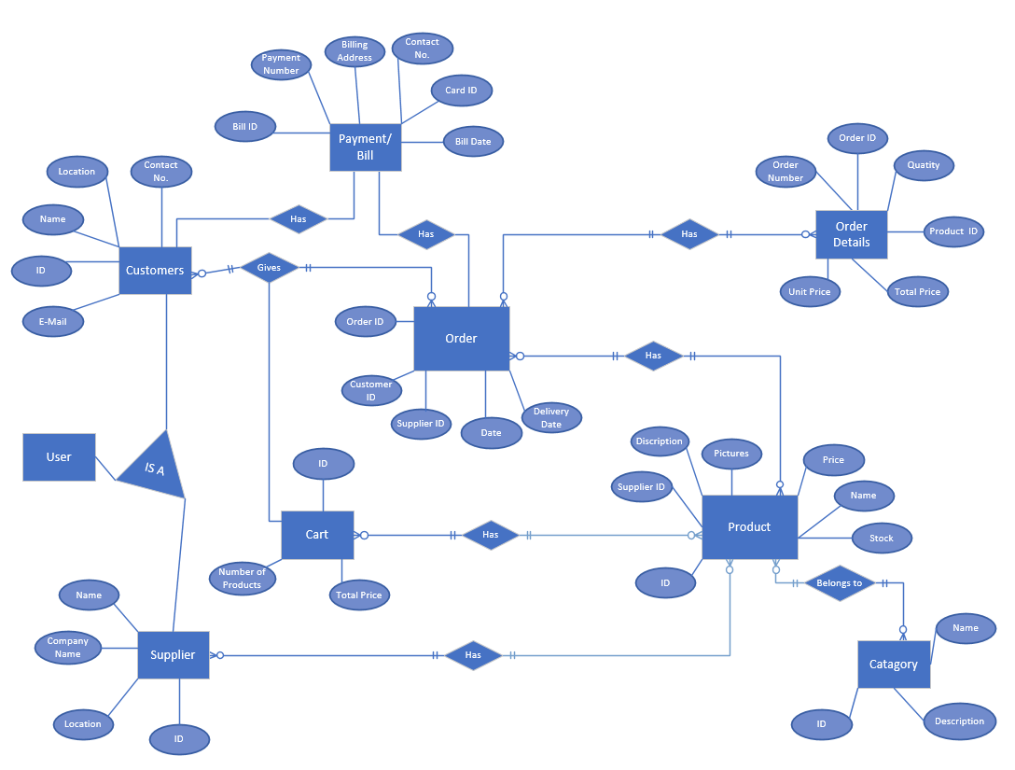

# Chapter 04

## Introduction

### Purpose of Document

The purpose of this document is to give a detailed description of the requirements for the “**Textile Auxiliaries**” software. It will illustrate the purpose and complete declaration for the development of system. It will also explain system constraints, interface and interactions with other external applications. This document is primarily intended to be proposed to a customer for its approval and a reference for developing the first version of the system for the development team.

### Project Overview

Many textile sites are contributing to this but no site provides everything from raw materials to finished products. For example, in OLX [1], the only ready-made cloth is available. We can't make our designs and colors. Similarly, there is another website called “Wal-Mart [2]” in which they also give the option to select the colors of the fabric, but even here we cannot design the fabric on our own. We can order by selecting one of the designs that they already have.

We are adding to them that we can produce goods in custom design, colors and quality. Like they can make their goods by sending their design to the seller. There are some things we are adding to it, such as the seller may request the buyer that we have to produce goods in such a design, colors and quality which the buyer provides. And also, the seller can upload his services to see what he is providing. This is beneficial for both parties as compared to the conventional system because it saves time and physical efforts like go and check the services of different industries. There are some advance and security features like privacy, tacking and monitoring of orders, analytics of seller, ratings, chatbots etc.

## Class Diagram

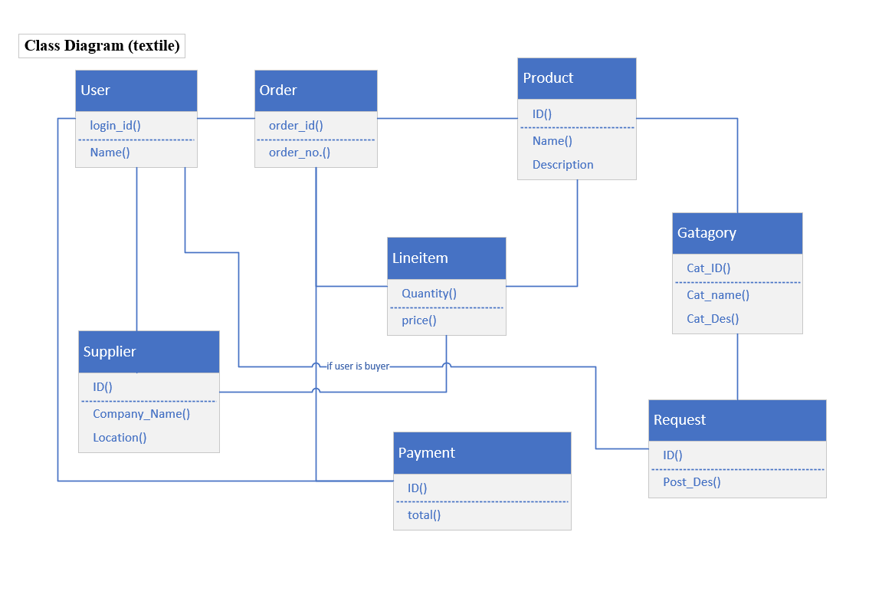

## System Sequence Diagrams

### Admin

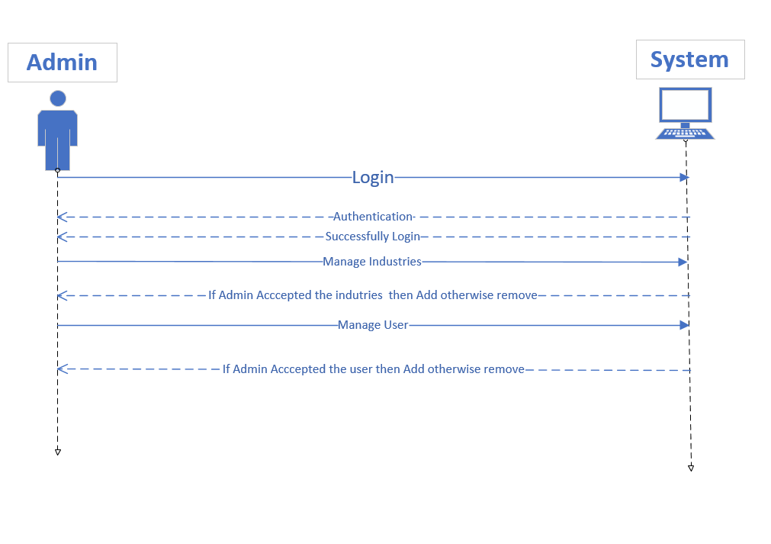

### Owner

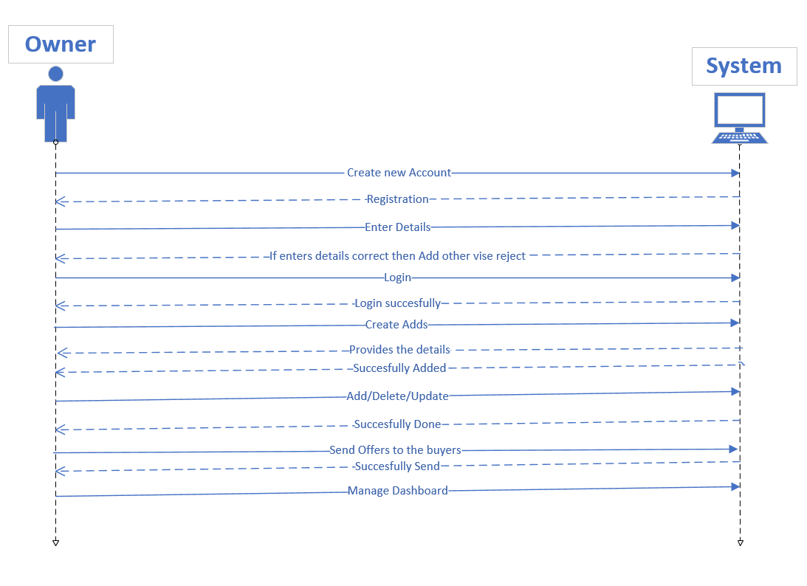

### User

